Statistics 231B SAS Practice Lab #3
Spring 2006

This lab is designed to give the students practice in conducting the Breusch-Pagan test for constancy of the error variance and a formal lack of fit test, obtaining joint interval estimates of regression coefficients using Bonferroni procedure, the simultaneous interval estimate of several mean responses and the predictions of several new observations.

Example: In a small-scale experimental study of the relation between degree of brand liking (Y) and moisture content (X₁) and sweetness (X₂) of the product, the data were obtained from the experiment based on a completely randomized design, see CH06PR05.txt.

(1) In lab 2, we have fitted the multiple linear regression model and obtained residual plots. The plots of residuals versus predicted values and predictor variables will suggest whether the variance of the error terms is constant. In fact, we can use Breusch-Pagan Test to formally test the constancy of error variance.

The Breusch-Pagan test is a large-sample test for constancy of error variance. It assumes that error terms are independent and normally distributed and that the variance of the error term ε_{i}, denoted by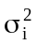, is related to the levels of q predictor variables in the following way:
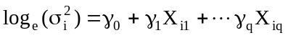
Note that above equation implies that either increases or decreases with the level of the q predictor variables, depending on the sign of γs. Constancy of error variance corresponds to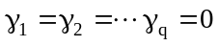. Therefore a test of H₀: can be carried out by
(1) fitting the following regression model :
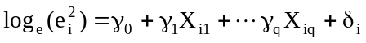
where δ_{i} is the error term for this regression model. The regression sum of squares can then be obtained and denoted by SSR*.
(2) obtain SSE, the error sum of squares from the following regression model:
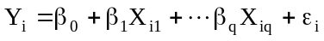
(3) calculate the test statistic 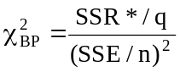 , which follows approximately the chi-square distribution with q degree of freedom when holds and n is reasonably large

(4)
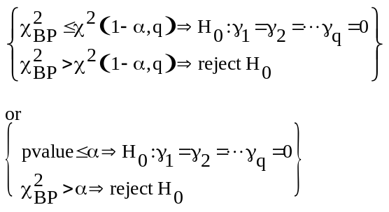

SAS CODE:

data Brandpreference;
infile 'Z:\ch06pr05.txt';
input y x1 x2;
proc reg data=Brandpreference;
model y=x1 x2/r p;
output out=results r=residual p=yhat;
run;
data results;
set results;
e2 = residual*residual;

proc reg data=results;
model e2 = x1 x2;
run;
quit;

SAS OUTPUT

Analysis of Variance

Sum of Mean
Source DF Squares Square F Value Pr > F

Model 2 1872.70000 936.35000 129.08 <.0001
Error 13 94.30000 7.25385
Corrected Total 15 1967.00000

Root MSE 2.69330 R-Square 0.9521
Dependent Mean 81.75000 Adj R-Sq 0.9447
Coeff Var 3.29455

Parameter Estimates

Parameter Standard
Variable DF Estimate Error t Value Pr > |t|

Intercept 1 37.65000 2.99610 12.57 <.0001
x1 1 4.42500 0.30112 14.70 <.0001
x2 1 4.37500 0.67332 6.50 <.0001

The REG Procedure
Model: MODEL1
Dependent Variable: e2

Number of Observations Read 16
Number of Observations Used 16

Analysis of Variance

Sum of Mean
Source DF Squares Square F Value Pr > F

Model 2 72.40700 36.20350 0.95 0.4113
Error 13 494.34723 38.02671
Corrected Total 15 566.75423

Root MSE 6.16658 R-Square 0.1278
Dependent Mean 5.89375 Adj R-Sq -0.0064
Coeff Var 104.62914

Parameter Estimates

Parameter Standard
Variable DF Estimate Error t Value Pr > |t|

Intercept 1 1.15875 6.85989 0.17 0.8685
x1 1 0.91750 0.68944 1.33 0.2061
x2 1 -0.56250 1.54165 -0.36 0.7211

For this example, please conduct the Breusch-Pagan test for constancy of the error variance, assuming 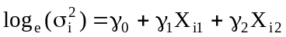; use α=0.01. State the alternatives, decision rule and conclusion.

(2) To ascertain whether a linear regression function is a good fit for the data, we can carry out a formal test called lack of fit F-test. The lack of fit test assumes that the observations Y for given predictor variables X₁, X₂, …, X_{p-1} are (1) independent and (2) normally distributed, and that (3) the distribution of Y have the same variance σ². The lack of fit test requires repeat observations at one or more Xs levels. Lack of fit F-test is a general linear test approach which compares the full model and reduced model:

Full model: 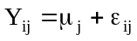
The full model stating that each response Y is made up of two components: the mean response when X₁=X_{1j}, X₂=X_{2j},… , X_{p-1}=X_{p-1j} and a random error term.
Reduced Model: 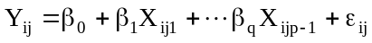
Note that here i refers to ith replicate observations, j refers to jth level of predictor variable X₁, X_{2,} … X_{p-1}.
The difference between the full model and the reduced model is that in the full model there are no restrictions on the mean μ_{I}, whereas in the reduced model the mean responses are linearly related to Xs. A test statistic was then developed to compare the error sum of squares from the full model and the reduced model as follows:

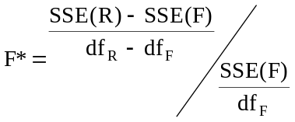
here 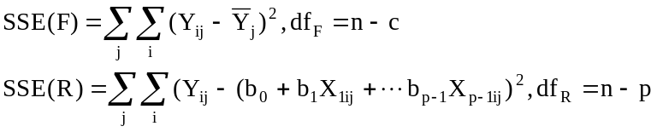
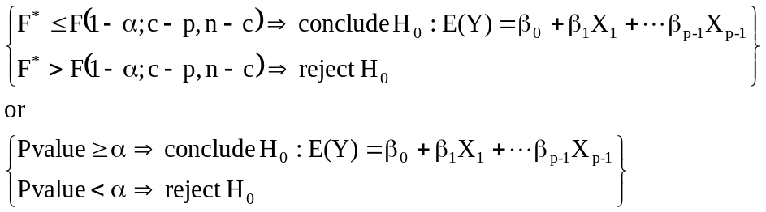

SAS CODE:

data Brandpreference;
infile 'c:\stat231B06\ch06pr05.txt';
input y x1 x2;
if x1=4 and x2=2 then j=1; /* create a new variable J*/
if x1=4 and x2=4 then j=2;
if x1=6 and x2=2 then j=3;
if x1=6 and x2=4 then j=4;
if x1=8 and x2=2 then j=5;
if x1=8 and x2=4 then j=6;
if x1=10 and x2=2 then j=7;
if x1=10 and x2=4 then j=8;
run;

proc glm data=Brandpreference;
class j;
model y= x1 x2 j;
run;

SAS OUTPUT:

The GLM Procedure

Class Level Information

Class Levels Values

j 8 1 2 3 4 5 6 7 8

Number of Observations Read 16
Number of Observations Used 16

The GLM Procedure

Dependent Variable: y

Sum of
Source DF Squares Mean Square F Value Pr > F

Model 7 1910.000000 272.857143 38.30 <.0001

Error 8 57.000000 7.125000

Corrected Total 15 1967.000000

R-Square Coeff Var Root MSE y Mean

0.971022 3.265162 2.669270 81.75000

Source DF Type I SS Mean Square F Value Pr > F

x1 1 1566.450000 1566.450000 219.85 <.0001
x2 1 306.250000 306.250000 42.98 0.0002
j 5 37.300000 7.460000 1.05 0.4530

Source DF Type III SS Mean Square F Value Pr > F

x1 0 0.00000000 . . .
x2 0 0.00000000 . . .
j 5 37.30000000 7.46000000 1.05 0.4530

To compute the Lack of fit F* in SAS, we switch to the proc glm procedure. We begin by fitting the full model to the data. This requires creating a new variable, J. Using the class j statement in proc glm , we specify that J is a classification variable. Thus, J identifies 8 discrete classifications based on the values of Xs. The SAS output shows that SSE(F)=57, SSE(R)-SSE(F)=37.3.

For this example, conduct a formal test for lack of fit of the first-order regression function; use α=0.01. State the alternatives, decision rule and conclusion.

(3) Joint Inference of several regression coefficientf.
The Bonferroni joint confidence intervals can be used to estimate several regression coefficients simultaneously. If g parameters are to be estimated jointly (where g≤p)), the confidence limits with family confidence coefficient 1-α are
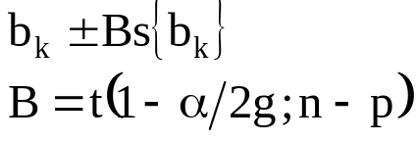

From

proc reg data=Brandference;
model y=x1 x2;
run;

We obtain the following estimates for regression coefficients and their corresponding standard deviation.

Parameter Estimates

Parameter Standard
Variable DF Estimate Error t Value Pr > |t|

Intercept 1 37.65000 2.99610 12.57 <.0001
x1 1 4.42500 0.30112 14.70 <.0001
x2 1 4.37500 0.67332 6.50 <.0001

Then use the code below, we can estimate β₁ and β₂ jointly by the Bonferroni procedure, using a 99 percent family confidence coefficient.

SAS CODE:

data intervals;
tvalue = tinv(.9975,13);
b1lo=4.425-(tvalue*0.30112); /*lower bound for b1*/
b1hi=4.425+(tvalue*0.30112); /*upper bound for b1*/
b2lo=4.375-(tvalue*0.67332); /*lower bound for b2*/
b2hi=4.375+(tvalue*0.67332); /*upper bound for b2*/
proc print;
var b1lo b1hi b2lo b2hi;
run;

SAS OUTPUT:

Obs b1lo b1hi b2lo b2hi

1 3.40948 5.44052 2.10425 6.64575

For this example, estimate β₁ and β₂ jointly by the Bonferroni procedure, using a 95 percent family confidence coefficient. Interpret your results.

(4) Estimation of Mean Response and Prediction of New Observation

A common objective in regression analysis is to estimate the mean for one or more probability distribution of Y. Let 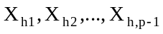 denote the level of Xs for which we wish to estimate the mean response 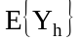. maybe a value which occurred in the sample, or it may be some other value of the predictor variables within the scope of the model. 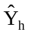 is the point estimator of :
- In terms of matrices:
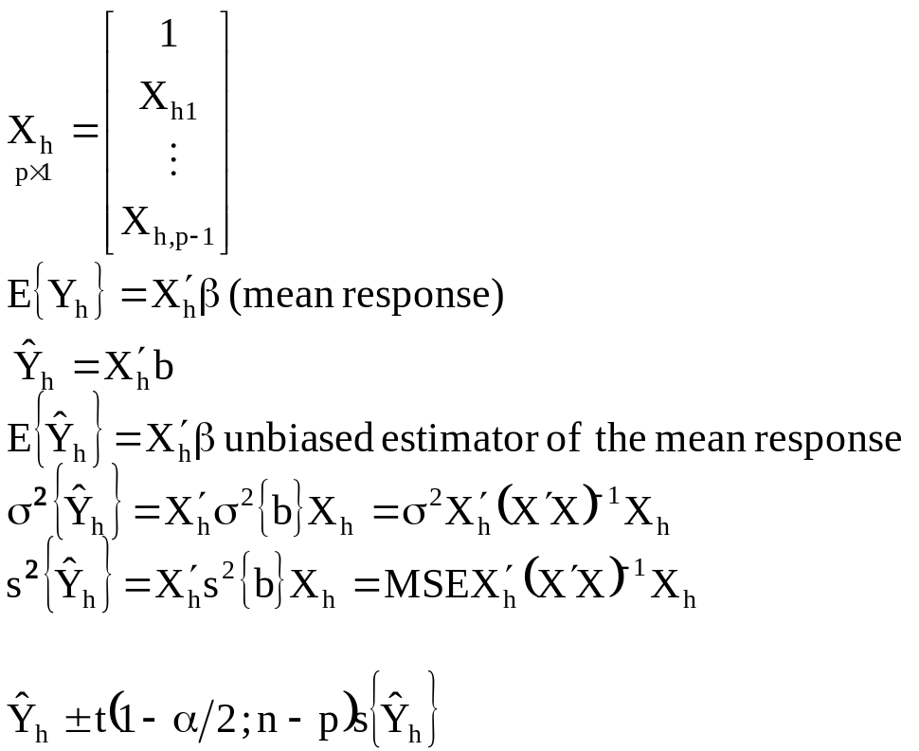

Prediction of New Observation
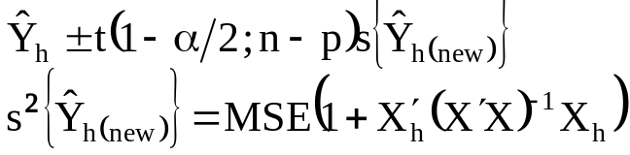

SAS CODE for obtaining an interval estimate of X_{h1}=5 and X_{h2}=4, using a 99 percent confidence coefficient.

data Brandpreference;
infile 'Z:\ch06pr05.txt';
input y x1 x2;
tvalue = tinv(.995,13);/*find t-value for a t(13) with alpha=0.01*/
x0 = 1;
proc iml;
use Brandpreference;
read all var {'y'} into y;
read all var {'x1'} into a;
read all var {'x2'} into b;
read all var {'x0'} into con;
read all var {'tvalue'} into tvalue;
x=(con||a||b); /*create X matrix*/
print x;
xtx=t(x)*x; /*create X’X matrix*/
print xtx;
xty=t(x)*y; /*create X’Y matrix*/
print xty;
b=inv(t(x)*x)*t(x)*y;/*create (X’X)^(-1)X’Y matrix*/
print b;
xtxinv=inv(t(x)*x); /*create (X’X)(-1) matrix*/
print xtxinv;
xh={1,5,4};
sxh=sqrt(7.25385*((t(xh))*(xtxinv)*xh)); /*7.25385 is MSE from*/
/*regression analysis*/
print sxh;
yhath = t(xh)*b;
print yhath;
yhathlo=yhath-(tvalue*sxh);
yhathhi=yhath+(tvalue*sxh);
low = yhathlo[1,1];
high=yhathhi[1,1];
print low high;
run;
quit;

SAS OUTPUT:

LOW HIGH

73.881108 80.668892

For this example, obtain an interval estimate of X_{h1}=5 and X_{h2}=4, using a 95 percent confidence coefficient. Interpret your interval estimate

SAS CODE for obtain a prediction interval for a new observation Y_{h(new)} when X_{h1}=5 and X_{h2}=4. Use a 99 percent confidence coefficient.

data Brandpreference;
infile 'Z:\ch06pr05.txt';
input y x1 x2;
b = tinv(.995,13);
x0 = 1;
proc iml;
use dwaine;
read all var {'y'} into y;
read all var {'x1'} into a;
read all var {'x2'} into b;
read all var {'x0'} into con;
read all var {'b'} into bon;
x=(con||a||b);

xtx=t(x)*x;
xty=t(x)*y;

b=inv(t(x)*x)*t(x)*y;
xtxinv=inv(t(x)*x);
xh={1,5,4};
spre=sqrt(7.25385+(7.25385*((t(xh))*(xtxinv)*xh)));
yhath = t(xh)*b;
yhathlo=yhath-(bon*spre);
yhathhi=yhath+(bon*spre);
low = yhathlo[1,1];
high=yhathhi[1,1];
print low high;
run;
quit;

SAS OUTPUT

LOW HIGH

68.480767 86.069233

For this example, obtain an prediction interval of for a new observation Y_{h(new)} when X_{h1}=5 and X_{h2}=4, using a 95 percent confidence coefficient.

Chi-Square Distribution Function (used for calculating pvalue based on Chi-square distribution)

probchi(x,df,nc) returns the value of the distribution function of the chi-square distribution with df degrees of freedom and optional non-centrality parameter nc. If not specified, nc=0. nc is the sum of the squares of the means. Examples:
y=probchi(3,17);
z=probchi(3,17,5);

Chi-Square Quantiles used for calculating Chi-square critical value based on Chi-square distribution)

cinv(p,df,nc) returns the pth quantile, 0<p<1, of the chi-square distribution with degrees of freedom df. If the optional non-centrality parameter nc is not specified, nc=0. nc is the sum of the squares of the means. Examples:
y=cinv(0.95,5);
z=cinv(0.95,5,3);

F Distribution Function (used for calculating pvalue based on F distribution)

probf(x,ndf,ddf,nc) returns the value of the distribution function of the F distribution with ndf numerator degrees of freedom, ddf denominator degrees of freedom, and optional non-centrality parameter nc. If not specified, nc=0. nc is the sum of the squares of the means. Examples:
y=probf(3.57,4,12);
z=probf(3.57,4,12,2);

F Distribution Quantiles (used for calculating F critical value based on F distribution)

finv(p,ndf,ddf,nc) returns the pth quantile, 0<p<1, of the F distribution with ndf numerator degrees of freedom, ddf denominator degrees of freedom, and optional nc as the non-centrality parameter. If not specified, nc=0. nc is the sum of the squares of the means. Examples:
y=finv(.95,3,12);
z=finv(.95,3,12,4);

T Distribution Function (used for calculating pvalue based on T distribution)

probt(x,df,nc) returns the value of the distribution function of the t distribution with df degrees of freedom and optional non-centrality parameter nc. If not specified, nc=0. nc is the value of the mean. Examples:
y=probt(1.96,10);
z=probt(1.96,10,3);

T Distribution Quantiles (used for calculating T critical value based on T distribution)
tinv(p,df,nc) returns the pth quantile, 0<p<1, of the t distribution with df degrees of freedom and optional non-centrality nc. If not specified nc=0. nc is the value of the mean. Examples:
y=tinv(.95,10);
z=tinv(.95,10,5);

